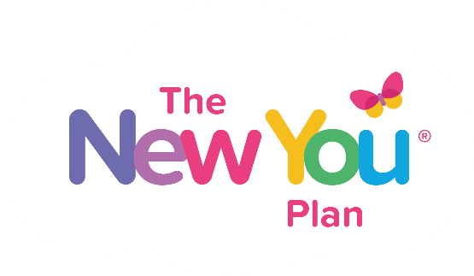

THE NEW YOU PLAN JULY PLANNER

This workbook has been created for people who are on TOTAL FOOD REPLACEMENT because they want to get to their healthy weight, stop the excuses, and start living the life they really want to live. This is for people who want to make REAL CHANGE and not make excuses.
This is for people who want to create A NEW YOU, and transform their lifestyle, habits, diet and mind set to support LONG TERM MAINTENANCE.
WARNING: If you are easily offended this workbook IS NOT FOR YOU. This is a straight talking, let’s make some real changes and get serious about CREATING YOUR NEW YOU. If you just kinda want to the diet, and just kinda want to change, this is NOT FOR YOU.
HOWEVER, … If you are sick and tired of saying the same thing every month that you want to lose weight and you are unhappy with your size and you want to finally master your weight and lifestyle and mind set to support a SLIM SEXY HEALTHY HAPPY NEW YOU, THEN THIS WORKBOOK IS FOR YOU.
PLEASE PRINT THIS OFF AND FILL IT IN WITH A PEN. YOU WILL GET SO MUCH OUT OF THIS EXERCISE, IF YOU REALLY WANT JULY TO BE AN AMAZING MONTH FOR YOU, INVEST THE TIME TO PLAN OUT YOUR PERFECT MONTH. I PROMISE YOU WILL NOT REGRET IT.

[PS Please excuse the design of this booklet,
it wasn’t made to look good, it was made to make YOU look good.]

DISCLAIMER
Total Food Replacement is NOT SUITABLE FOR EVERYONE. You MUST get your doctors approval before starting a very low calorie diet plan. You need a BMI of 25 and no health problems. PLEASE MAKE SURE YOU DO NOT START THE PLAN WITHOUT SEEKING AND FOLLOWING YOUR DOCTORS ADVICE.

INTRODUCTION
July is here and this workbook will help you to get LASER FOCUSED on creating your NEW YOU! Whether you are already in your groove with the NEW YOU diet plan, or whether you are just getting started, it is always good to plan your month and set some goals. This will give you more focus and make you feel like you have something to work towards. Take the time now to schedule your success and you will not regret it.
Every Sunday keep your eye out for our weekly planner so that you can refocus on your monthly goals each week.
THIS PLANNER INCLUDES:-
- Starting point – establish where you are now.
- Get committed to a SUMMER MAKEOVER MISSION
- Weight Loss Goals
- Personal Goals
- Habit Goals
- Mindset Goals
- Rewards
You want to have a clear vision of where you want to be in July, and you want that vision to EXCITING so that you can really enjoy the process and when you have hard days come (they will happen!!) you have your vision to get you through the day.
You need to remember that YOU ARE WORTH THIS. This is YOUR TIME to make the CHANGES you want and need to get you to a healthier happier place.
IF IT DOESN’T CHALLENGE YOU, IT DOESN’T CHANGE YOU.
This month will have it’s challenges, if you want real change, you will not let the challenges beat you, you will beat your challenges…. Every challenge you win, you will get stronger and this process of creating your new you will become easier. But you need to be willing to fight this battle
Rome was not built in a day.
This is a journey, but month by month, week by week, day by day, hour by hour you will get there!
If you have a plan you have a better chance of success. Make this plan something that inspires and motivates you to be your best self.
YOUR STARTING POINT
Get clear on where you are today. Even if you do not want to know the numbers. FACE THE TRUTH. Get clear on where you are today. Get clear on what you weigh, what you look like, how big your waist is, and what your BMI is. You will not like the figures, but take heart that this is the WORST these figures will ever be, from this day on, these figures are only going to improve as you create your new you!
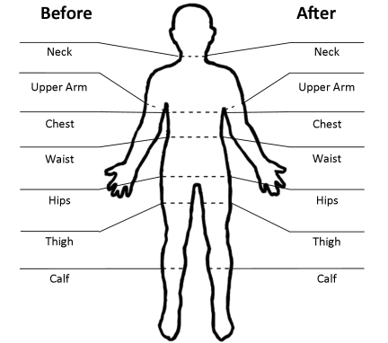
Your numbers represent the truth of your health today, and these numbers are your starting point. This is what you are working on, improving these numbers, as these numbers are a measurement of your health, your diet, your lifestyle, your habits, your discipline and your self-talk. You need to improve all of these to see these numbers improve. The diet is only part of it; your commitment to change is the biggest part.
PLEASE MAKE SURE YOU TAKE A BEFORE PHOTO. Front, side and back. This will be great for you to look back on. You might never want to show anyone these photos, but trust me, you will feel an amazing sense of achievement when you look back on what you have achieved when you get to your goal. So many people regret not taking the photo. Don’t make the mistake of not capturing where you are today!
Take your key body measurements now, at the end of the month you can record your progress and fill in the end of July boxes.
 | START JULY |  | END JULY
Body Area | Left | Right | Left | Right
Neck
Upper Arm
Chest
Waist
Hips
Thigh
Calf
Total

 | START JULY | END JULY
Weight

BMI (google BMI calculator to find out)
Clothes Size TOP

Clothes Size BOTTOM

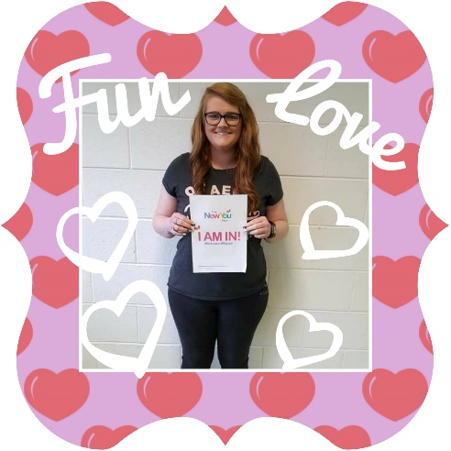
ENTER THE #MChallenge TODAY and be in for the Chance of Winning a VIP #Makeover and become the face of New You 2017
We have a #MChallenge #Makeover competition to keep you focused and motivated for the full summer!
On August 17th we will pick one lucky slimmer to win a VIP MAKEOVER in Belfast! All expenses will be paid for this for you!
To be in with a chance of winning this AMAZING prize here is what you need to do….
- You need to sign up for the #MChallenge (you can find the link at the bottom on the blog on the website to sign up)
- You will need to submit the photo to The New You Plan, by emailing it to support@thenewyouplan.com and that’s it! You are in with a chance of winning this phenomenal prize! Easy! You do not have to post the photo on social media if you do not want to, and we will never show anyone without your permission.
- You will be sent information on how to do this after your register for the challenge.
- Sign up for the JULY WEIGHT LOSS CHALLENGE and update your weight loss every week. You can do this on our blog on our website. This will help you to feel accountable. We will have a new weight loss challenge every month this summer.
- At the end of the summer we will ask everyone to take a photo with the I DID IT sign, then you can submit your I AM IN photo and your I DID IT photo together if you want to be considered for the #MChallenge #Makeover prize!
GOOD TIP!! Print of the I DID IT poster now and put it somewhere you can see every day (You will find it at the end of this work book). This will affirm in your mind that YOU ARE GOING TO DO THIS!! And it will keep your eyes on the prize of a new you and a chance of winning an amazing VIP makeover!

YOUR WEIGHT LOSS GOALS
How much weight you lose this month depends on A LOT of factors.
Sex (men lose more!! Lucky ducks!), Age, Activity Level, Amount of weight to lose… these are all key factors.
If it is your first month on the diet you will also have a bigger loss, your first week is usually big, could be anything from 5 pounds to 15 pounds! Or Even more! Most of the weight in the first week is water weight and glycogen. After the first week you should settle down to approximately 1 stone a month for women and 1.5 stone a month for men, this is not guaranteed but it is very very common that these averages happen.
You do not have to exercise to lose weight with this plan. Many of our customers are people who cannot exercise, and that is why the weight has piled on. If you do have mobility problems, you might find that as you lose the weight you are more able to become active.
We do encourage you to be active, not necessarily to boost weight loss results, but more for the fact that if you are serious about creating a NEW YOU, you need to build exercise and healthy habits into your lifestyle.

STATE YOUR WEIGHT LOSS GOAL
On 30th July I want to weigh
______________________________________________________
To achieve this I need to lose ___________ pounds / kgs
I want my BMI to be
(google BMI calculator and enter your goal weight for end of the month)
_______________________________________

I want my clothes size to be
Top __________________________________
Bottom _________________________________

YOUR PERSONAL GOALS
This month is going to be amazing for weight loss, but you might also want to set some goals to improve other areas of your life.
- Your home / garden / car / decluttering / decorating
- Your work / business / professional skill base
- Your family life / love life / quality time / creating special moments
- Your hobbies / pass times / crafts / creativity
- Your voluntary work / church / charity work
- Your exercise / yoga / walking / swimming / ab challenge / squat challenge
- Your beauty goals / skin / hair / nails / makeup / accessories
What do you want to do this month that you have been putting off??
Pick 3-5 things that will make the biggest impact to your level of happiness.

MY PERSONAL GOALS FOR JULY
1.
2.
3.
4.
5.

When you are improving other areas of your life you will increase your self-esteem and sense of new change and improvement, this will help you to stay focused on your diet and a new way of healthy eating and living when you get to your goal.
You will have more time when on a TFR diet, use this time to do things that will improve your life and make you feel better.

YOUR HABIT GOALS
When you are on (TFR) TOTAL FOOD REPLACEMENT, this is the PERFECT TIME for you to build in some healthy habits. Having a break from food gives time to focus on your lifestyle and habits, these are the foundation of WHO YOU ARE. If you want to create a NEW YOU it all starts with your habits.
Habits you want to build in…
- Water
- Exercise
- Sleep
- Planning
- Journaling
- Personal Care
- Waking up early
WATER
We recommend that you drink between 2.5 - 4 litres of water each day throughout the day. This is a good habit to keep up AFTER total food replacement.
EXERCISE
Daily exercise is also good to build in. If you are just starting out on the diet you will want to focus on light exercise for the first couple of weeks. When exercising listen to your body, push yourself without over doing it. The key here is to build the HABIT of exercise, so that when you come off total food replacement you ALREADY HAVE THE HABIT and then you can start to build the intensity. Total food replacement is a short term diet, this is to give you a platform and spring board to create your new you. Use this time to build in the habit of exercise.
SLEEP
Too many people don’t get enough sleep. You need your sleep so that when you wake up in the morning you feel refreshed. If you have bad habits of going to bed too late, being on your phone in bed (that blue light is not good for sleep!) Make it your mission to break these bad habits and build in the healthy habits and routines that will set you up for a good sleep. Research has shown that people
‘’ who don’t get enough sleep tend to be heavier as they eat more during the day to give them energy.
PLANNING
A lot of times diet and healthy eating plans fail is because of lack of planning. When you come off TFR you need to be REALLY good at planning to make sure you always have healthy meal options planned in advance. Get serious about planning now.
- Every week make sure that you have enough meal replacements to see you through the week. It is better to buy a monthly bundle or our SIX WEEK SUMMER SLIM DOWN BUNDLE (ONLY £199.99 / €257.99 for 6 weeks this includes lots of accessories to help you on your journey!!
- Make sure you keep an emergency supply of meal replacements in your desk or locker at work, and in your car, or in your handbag. That means if you ever forget to bring your products out with you, you still have access to products.
- If you want to start exercising, or swimming, get organised and get your gear together in advance so that you have no excuses!
JOURNALLING
This is a fantastic habit to have, if you can journal your way through this journey, it will be amazing to look back on, you will learn so much about yourself and it will help you to reflect on what triggers you to eat due to stress or emotions. You can get our 21 Day Drop a Jean Size journal that will help you through the first 21 days (crucial time in your diet for building habits and breaking old habits). Or you can get a plain page journal (I love paper blanks brand!)
If you don’t think you can make the habit of journaling, then make it a habit to post every day in our secret slimmers group.
PERSONAL CARE
A lot of times people put on a lot of weight due to some problems in life, and that can mean you lose your habits for personal care, whether that is your skin routine, wearing makeup, doing your hair nice, wearing nice clothes etc. If you have let these things slip then start this month to build them back into your life.
Remember the busier you are building healthy habits into your life…
- The less time you have to think about food
- The less chance you have of breaking the diet through boredom
- The less time you will spend on the sofa being a couch potato
- The more you are affirming to yourself that you are worth it
- The more chance you will have of making sure this is your last ever diet
- The better you will feel about yourself and the quality of your life
WAKING UP EARLY
How you start your day will dictate how your day goes. Your day is your life in miniature. So be determined to start your day well. Get up early. Have a good morning routine that sets you up for the day. Look good, feel good, be focused on the day ahead and it will work out a good day for you. If you wake up late, feeling tired, disorganised, rushed and in a bad mood…. Guess what your day is going to SUCK!! If you do this every day… your life will SUCK! And if your life sucks, then you are going to want to eat and drink to feel better and you are always going to struggle with your weight.
WHAT HABITS ARE GOING TO FOCUS ON TO BUILD YOUR FOUNDATION FOR A LONG TERM NEW YOU?
You can use the weekly planner & habit checker to keep track of your habits & goals for the week!
WEEKLY HABIT CHECKER Wk Beginning ___________
Tick each box as you complete the habit.
YOUR HABITS | M | T | W | T | F | S | S | Total
TFR
100%
Water
4 lts

TOP 5 PERSONAL GOALS THIS WEEK | MY TOP 5 WHYS TO LOSE WEIGHT
1 Lose ____ pounds  2  3  4  5 | 1  2  3  4  5
MY MOTTO FOR THE WEEK

MY REWARDS & TREATS THIS WEEK

YOUR MINDSET GOALS
This TOTAL FOOD REPLACEMENT diet is really a head diet. Especially in the first 21 days when you are breaking those bad habits of opening the fridge every evening, or having a wee something with your cup of tea. Your head is going to keep telling you that you cannot do this, get real with your answers ahead and don’t be your own worst enemy this month…
I can’t do this > You CAN DO THIS. There is nothing in this that is outside your skill base. Make a shake, drink it. Open a meal bar, eat it. It is actually very simple to do. If your head is in the right place and you are focused and determined.
I need to eat to feel better > The first few days / first week can be challenging at times. Recognise this in advance. Know that you are more than likely going to feel this way. Make sure you have your products regulary and don’t leave it too long in between. Drink your water, have a bath, go for a walk. You can feel better loads of ways, you do not need food to feel better. Listen to your favourite music, or do something else that will make you feel better.
This is too hard for me > This is hard. This is short term pain, for long term gain. Living life feeling overweight and not fitting into your clothes is HARD. Choose your hard.
I am always going to be fat, what’s the point > You will always be fat if you keep doing what you are doing and don’t make change. If change doesn’t challenge you, it won’t change you. You want to change your weight, it is going to challenge you. Love the challenge!! Bring it on!
Sure life is for living, im not doing this diet anymore > LIE LIE LIE!! This is total BS!! Don’t even let yourself entertain this thought. This is absolute rubbish. Don’t live to eat. Eat to Live. Make it your personal mission to live a life that is fulfilling that does not require you to eat to make you feel like you enjoy your life. This is not a LONG TERM thing. Food is not going anywhere. You can enjoy plenty of healthy meals when you get to your target. Settle yourself on your dedication to the meal replacements until you get to your goal, and then you can REALLY LIVE THE LIFE YOU WANT…. And not have to settle for a life that you let your weight dedicate what you do and where you go.
What’s the point of doing this diet if I am going to be miserable > So why did you start the diet?? Was it not because you felt miserable in the first place? After the first week or so when you have completed your detox from carbs and junk food you will feel better than you have felt in months / years. Every customer says the same thing, that they FEEL AMAZING on the plan. So fight through those early days and you will be rewarded. Or give up and feel miserable anyways… like you did before you started the plan. Your choice!
I am just going to do healthy eating, I can’t do this > Great, do that! But my guess is you TRIED THAT BEFORE YOU TRIED MEAL REPLACEMENTS? And obviously if you bought meal replacements then that did not work for you!! Losing weight is HARD. If you have a lot to lose, losing 1 or 2 pounds a week (with those weeks where you stay the same or put on pound or 2 on inbetween) it can be one of the most demoralising things to even contemplate. This diet is strict. But give it 100% and you will get 100% results… then when you get to your goal weight you can follow a healthy eating plan to maintain, and not to lose weight, which will be much easier for you to do.
BE PREPARED FOR TALKING YOURSELF AROUND WHEN YOU GET A NEGATIVE MINDSET.
THE BIGGER YOUR WHY, THE EASIER IT WILL BE FOR YOU TO STAY FOCUSED AND POSITIVE.
GET CLEAR ON WHY YOU ARE DOING THE DIET AND WHAT IT MEANS TO YOU.
Complete the task on the next page!

MY WHY
My Top 10 Reasons Why I WILL Do This!
1.
2.
3.
4.
5.
6.
7.
8.
9.
10.

Anytime you need to get back into a positive mind-set this month, read through this planner and remind yourself of these 10 reasons WHY you NEED to do this diet and get to your target healthy weight.

REWARDS
Recognising your success and rewarding your effort is important. It can be something simple!
A new nail varnish, face cream, eyeshadow, book, hand bag, candle lit bath, shoes, holiday, city break, home improvements, perfume, phone, kindle, slender tone belt, wii fit, spa treatments…
You can plan rewards for getting into ketosis, doing 1 day 100%, doing 1 week 100%, doing 1 week shakes only, getting into the next stone bracket, losing 7 pounds, losing 14 pounds, moving into a lower BMI category. You can also reward yourself for sticking to your habits. Give yourself mini goals to focus on and reward yourself along the way.
How are you going to reward yourself this month? Get motivated and get excited.
MY TREATS & REWARDS THIS MONTH
Milestone __________________________________________________
Reward __________________________________________________

Milestone __________________________________________________
Reward __________________________________________________

Milestone __________________________________________________
Reward __________________________________________________

Milestone __________________________________________________
Reward __________________________________________________

Milestone __________________________________________________
Reward __________________________________________________

Milestone __________________________________________________
Reward __________________________________________________

